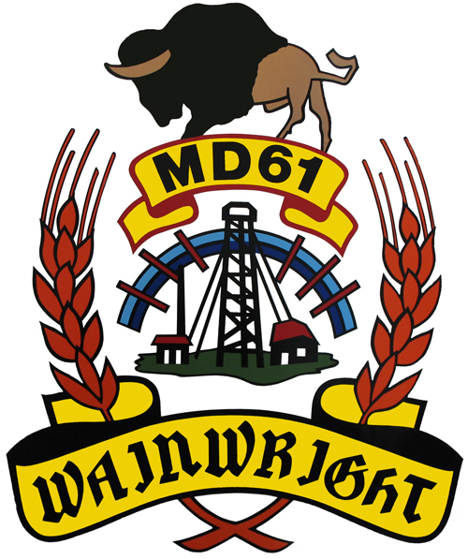

2021 Election
Candidate Package

Running for Municipal Office

On behalf of the M.D. of Wainwright No. 61, please accept this nomination package for the office of Councillor for the M.D. of Wainwright. Please note this information package has been provided for your assistance; however, it is not inclusive of all the information contained within the specific acts, regulations and other legislations. If you have any questions about running for office, please do not hesitate to contact the Returning Officer, Neil Loonen or the Deputy, Substitute, Returning Officer Tyson Boomhower at (780) 842-4454 or by email at nloonen@mdwainwrgiht.ca or tboomhower@mdwainwright.ca.

The M.D. of Wainwright No. 61
The M.D. was incorporated on January 30th, 1942 and is comprised of a total area of 4,134 square kilometers including approximately 600 square kilometers for the Canadian Forces Army Training Base (Wainwright Area Training Center). The municipality is divided into 7 Divisions and has a population of approximately 4,479 residents.
The M.D. has 2,315 kilometers of local roads and features 4 fire areas, providing emergency services to all residents. There are also many recreational areas, including Arm Lake, Clear Lake and Shuster Lake, Riverdale Golf Course and Campground, Arm Lake Golf Course and Campground, Koroluk Landslide, the Wainwright Railway Trestle, Dillberry Lake Provincial Park, and two roadside campsites near Ribstone and Fabyan.

Term

You will be elected for a four (4)-year term of office which expires in 2025 and during that time you will be required to attend:

- regular meetings of council which is set at the organizational meeting each year. Currently there are (12) they are the 3rd Tuesday of every month. This will remain the same unless otherwise changed;
- special meetings called by council as needed;
- meetings of other committees, boards and agencies that you have been appointed to as a council representative (example Recreation board, Fire Board, ASB, Health Foundation, Lodge, etc.);
- conferences, conventions, seminars and workshops for training; and
- social and other events promoting your municipality.

What other information should you have?

The best way to find out what the job is all about is to spend some time reading Council agendas and minutes and by talking to current or past members of Council and/or the CAO, Kelly Buchinski. This will be helpful with your campaign and will assist you in assuming office if elected. Council minutes are available on the M.D. website at www.mdwainwright.ca. All current and past bylaws are available through the administration office as per request.

Nomination Day

- Make sure your nomination form (attached) is signed by at least five (5) eligible voters who are residing in the division you plan to run in.
- Submit the nomination paper (attached in this package) to the Returning Officer on Nomination Day, Monday, September 20, 2020 at the M.D. Administration Office by 12 noon. Nominations will not be received after 12:00 p.m. (fax or email will not be accepted).
- Each nomination paper must be accompanied by a $100.00 deposit in cash, certified cheque, money order, or debit transaction. Personal Cheques will not be accepted.
- If you wish to withdraw your nomination, you must do so in writing prior to 24 hours after the close of nominations (i.e. before 12 noon on September 21, 2021).
- Your notice of withdrawal must be submitted in writing to the Returning Officer.
- If only the minimum nominations are received on Nomination Day, the candidates nominated will be declared elected (by acclamation) by the Returning Officer after the close of nominations.
- If more than the minimum nominations are received on Nomination Day, an election will be held on Election Day.

Election Day

Election Day will be on Monday, October 18, 2021 from 10:00 a.m. until 8:00 p.m. The Advanced Vote date is to be determined. The date of the Advanced Vote will be advertised, or you may inquire about the date with the Returning Officer in late August.

Voting Stations

Voting Stations for the 2021 Election will be confirmed by bylaw as per the Local Authorities Election Act. If there is an election in any or all divisions, the voting stations will be located as follows:

Division 1 To Be Determined previous was Chauvin Hall
Division 2 To Be Determined previous was Edgerton Agricultural Hall
Division 3 To Be Determined previous was Rosedale Hall – SE 4-46-4-W4M
To Be Determined previous was Edgerton Agricultural Hall
Division 4 To Be Determined previous was Wainwright Communiplex
Division 5 To Be Determined previous was Wainwright Communiplex
To Be Determined previous was Riverdale Family Centre – NW 29-46-6-W4M
Division 6 To Be Determined previous was Irma Legion Hall
To Be Determined previous was Fabyan
Division 7 To Be Determined previous was Irma Legion Hall
To Be Determined previous was Albert Hall – NW 36-47-9-W4M

Unofficial Election Results

Unofficial election results will be available as soon as possible after the voting stations close. The unofficial results will be placed on the M.D. website at www.mdwainwright.ca the following day. Candidates may call (780) 842-4454 to get unofficial election results on the evening of the election.

Official Election Results

Official results of the election will be posted on www.mdwainwright.ca and in the M.D. Administration Office at 12 noon on the 4th day after Election Day (October 19, 2021).

Copy of the Election Act

Copies of the Local Authorities Election Act may be obtained from:

The Queens’s Printer, Publication Services
Main Floor, Park Plaza
10611 – 98 Avenue
Edmonton, Alberta T5G 2Y5
Telephone: (780) 427-4952
Fax: (780) 452-0668
www.qp.alberta.ca (Laws online catalogue)

